1. **Setup additional swap space in the system to solve low memory issue.  The swap which you added should be available post reboot.**

Ans:

* To create a swap file used the **dd** (data dump) command to take a input file and create an output file in the root of size 1GB mentioned in **bs**(block size) and **count**.
* Changed the permission of file to **600** using **chmod** so that only user can access this.
* Created a swap area for the file: **mkswap** /path
* To activate the swap file I used the command **swapon**.
* To check swap file is created or not : **swapon –show.**
* To activate the swap file automatically post reboot I edited the **/etc/fstab** and added the details of the swap file so that swap space should be mounted during startup.

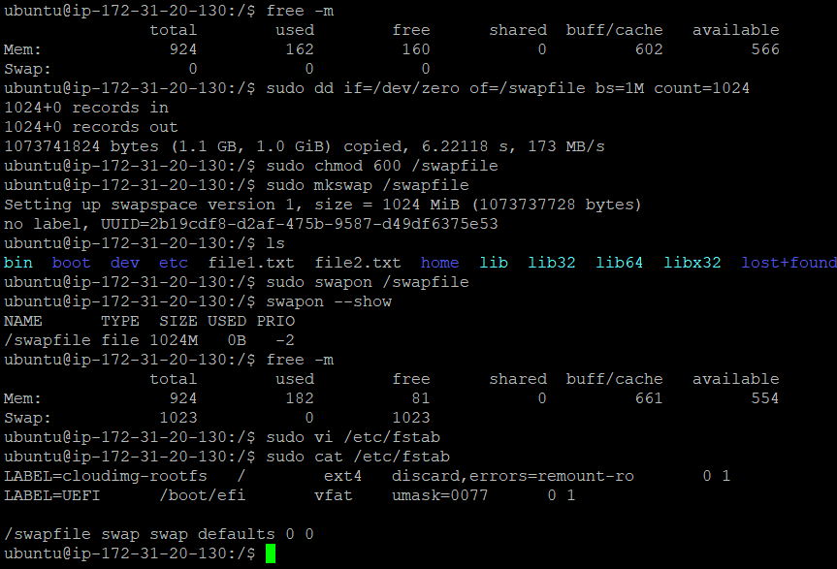

1. **Find out the number of process is in run queue and blocking queue.**

Ans:

* To monitor the no. of process which are in running and blocking queue: Used the vmstat which reports virtual memory statistics.
* Syntax : {**vmstat n m**} : where n is the interval in seconds and m stands for the count of rows.
* r : stands for running queue & b : stands for blocking queue.

